EXPT NO:6A | DATA VISUALIZATION USING POWER BI

AIM:
To import, transform, analyze, and visualize data using Power BI Desktop and create interactive dashboards and reports for decision-making.
ALGORITHM:
- Start the Power BI application.
- Import the Research Student dataset into Power BI using Get Data.
- Load the dataset into Power BI.
- Check the columns and clean the data using Power Query if required.
- Remove duplicate records and handle missing values.
- Create required calculated fields/measures.
- Create a bar chart to compare student-related categories.
- Create a pie chart to display category-wise distribution.
- Create a line chart to represent trends between numerical attributes.
- Create a card visual to display important summary values.
- Add suitable titles, labels, filters, and slicers.
- Arrange the visuals into a Power BI dashboard.
- Analyze the visualizations and identify important patterns.
- Save the Power BI report.
- Stop.
OUTPUT:
Importing Data into Power BI:

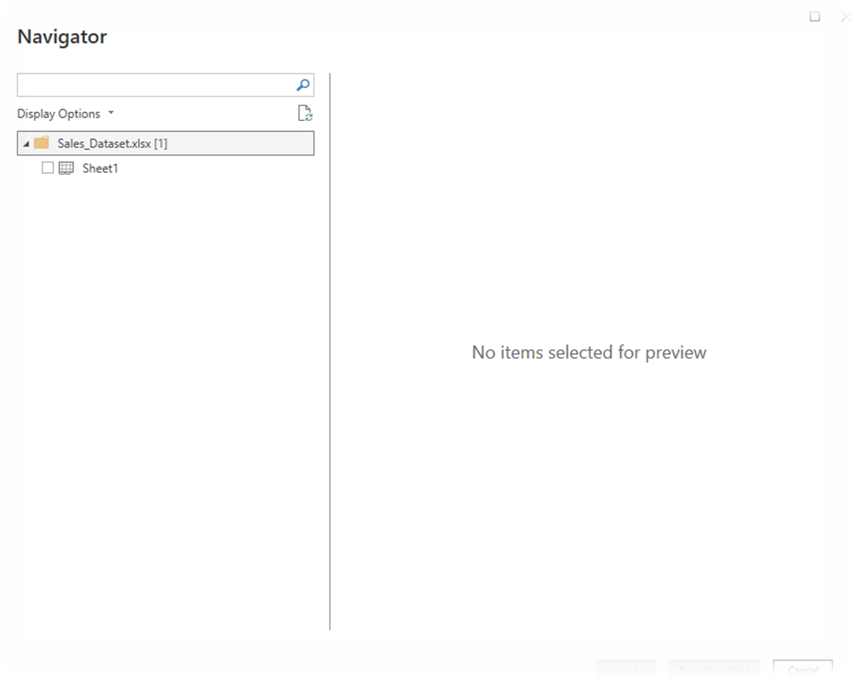
Imported dataset displayed in Data View:

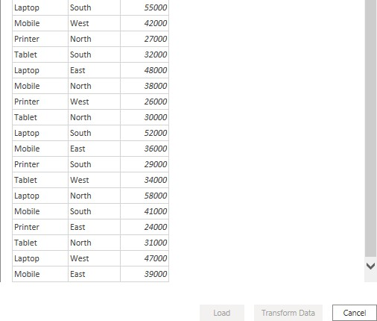
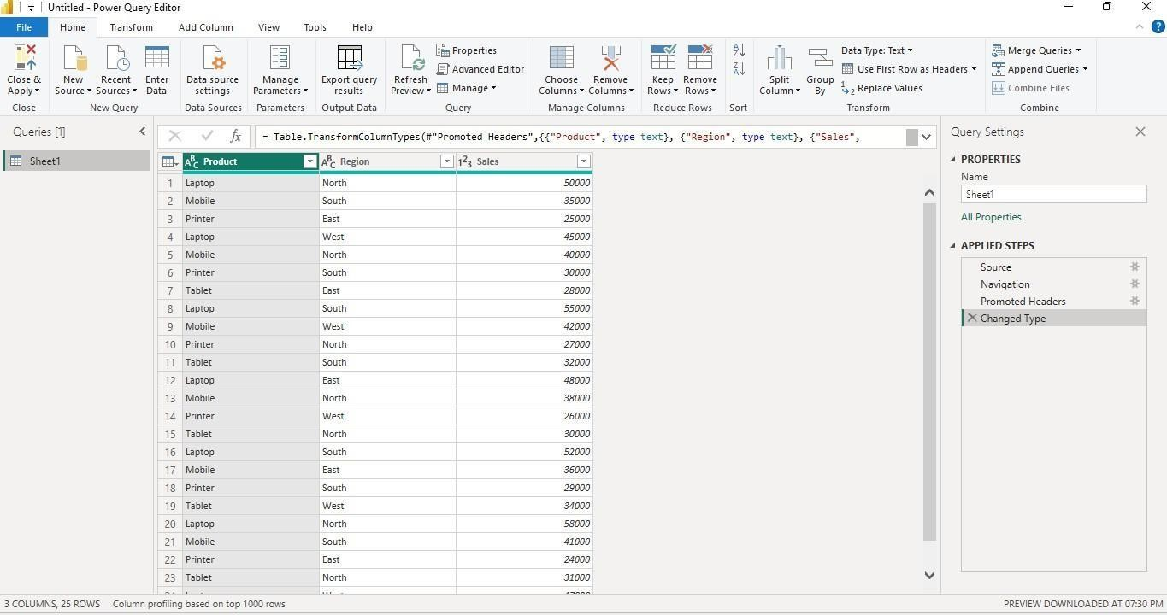
Cleaned dataset loaded successfully:

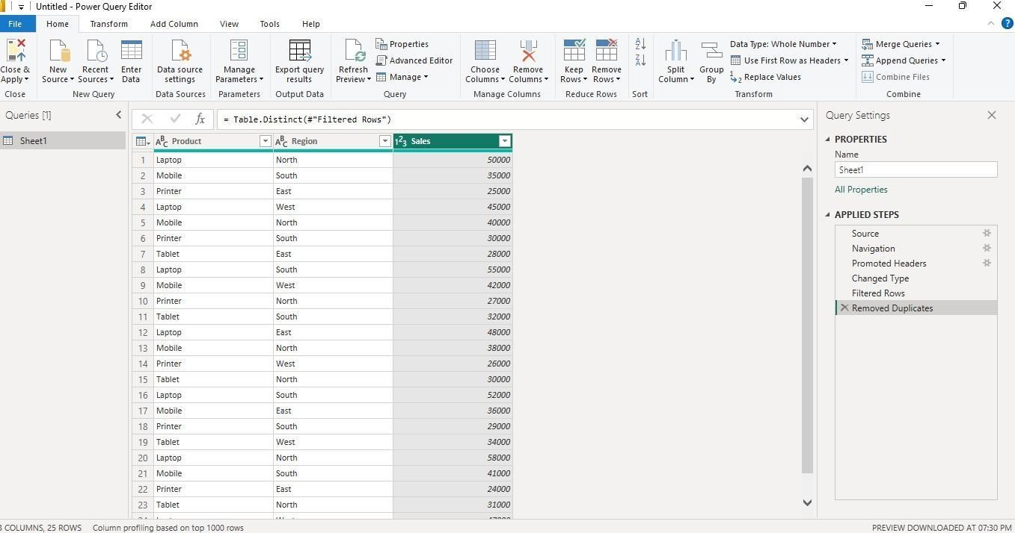
Creating a Bar Chart
Product-wise Sales
Sales comparison across products.
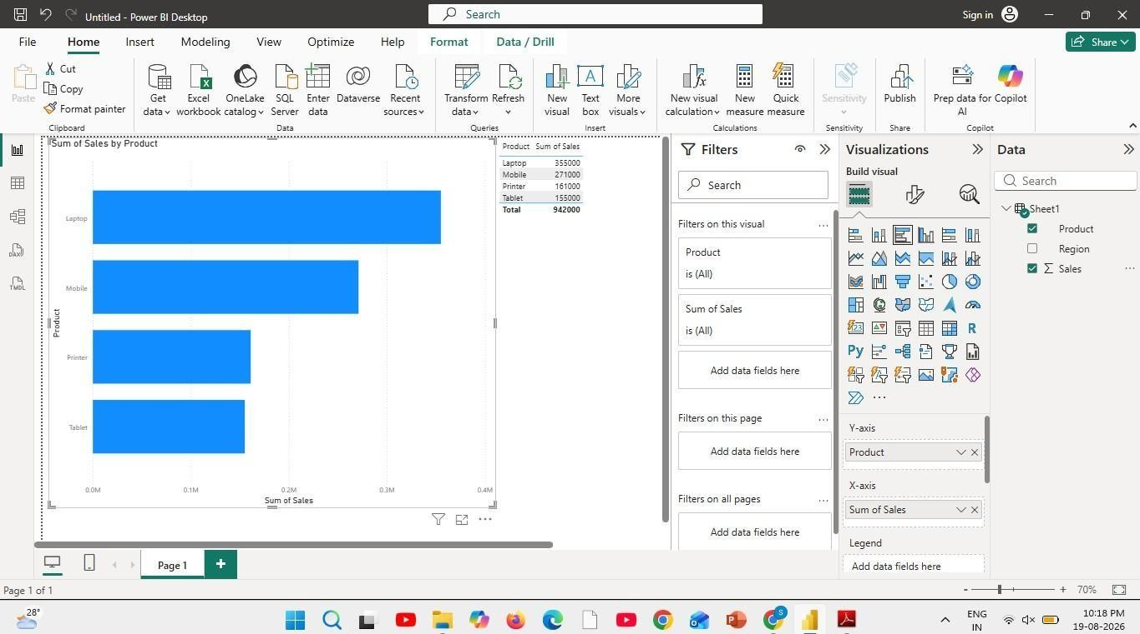
Creating a Pie Chart
Sales Contribution
Percentage contribution of each product

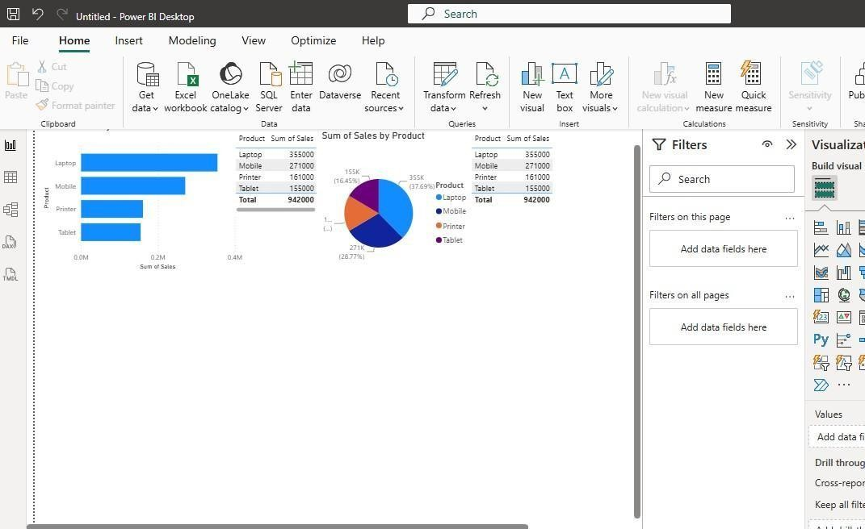
Creating a KPI Card
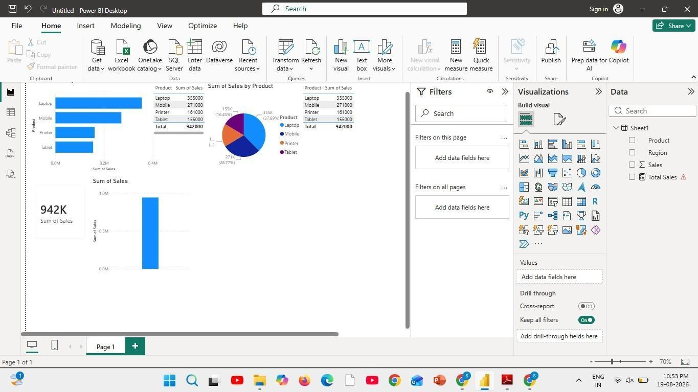
Creating Slicers:

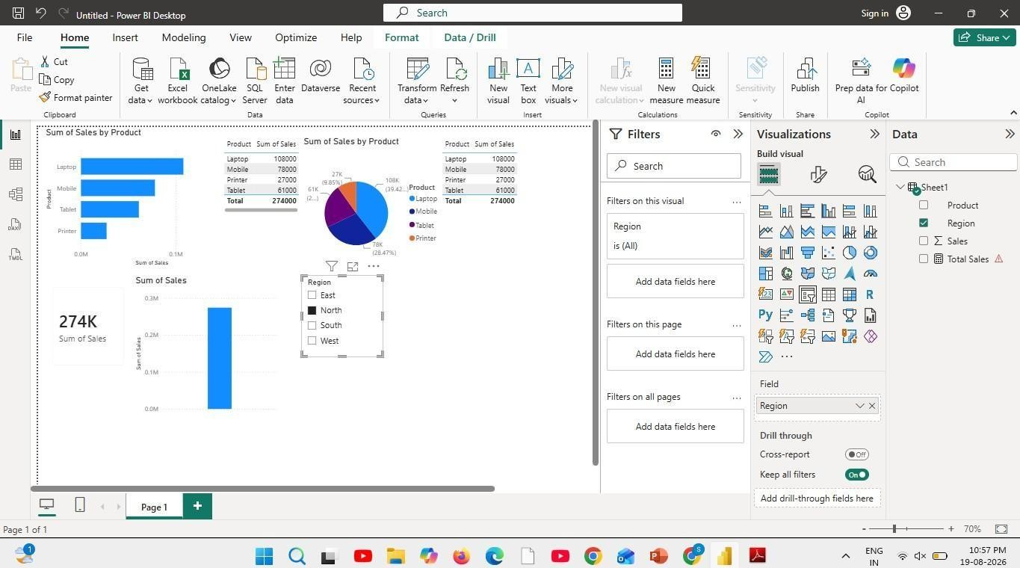
Creating DAX Calculations:
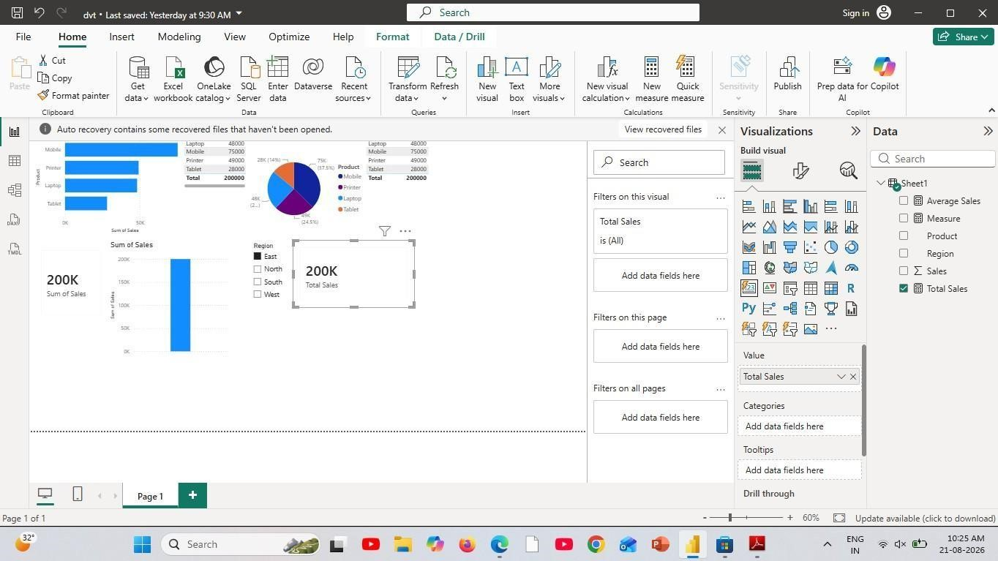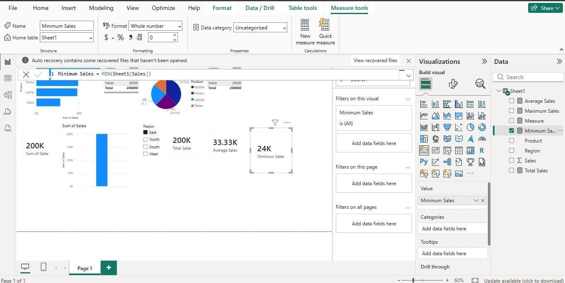
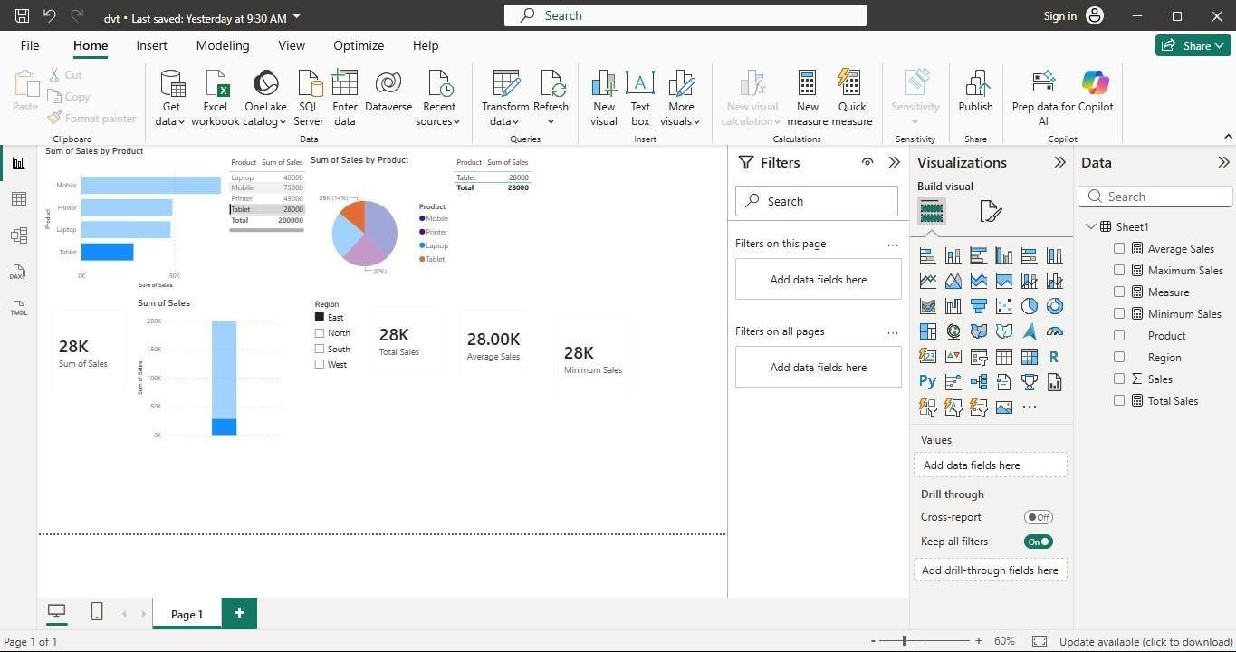
Creating Dashboard:

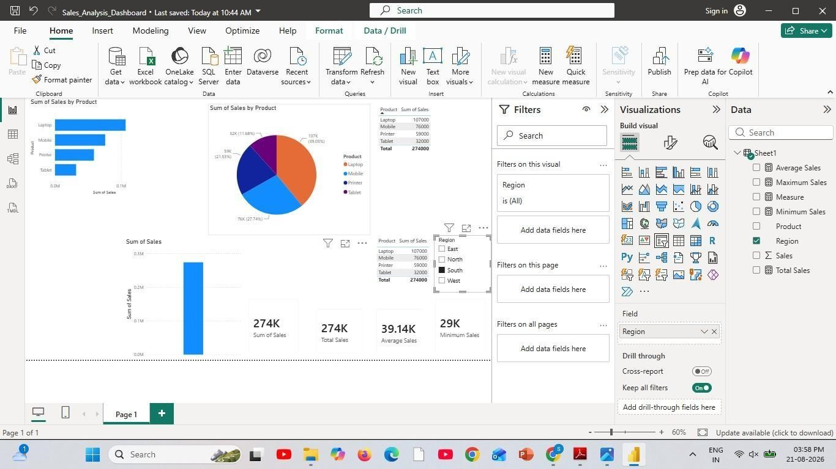
Result:

